SPRINT 3

|  |  |
| --- | --- |
| Date | 14 November 2022 |
| Team ID | PNT2022TMID33194 |
| Project Name | Smart Farmer-IoT Enabled smart Farming Application |

Creating Mobile app using MIT app Inventor SMART FARMER APPLICATION

App Inventor + IoT can work together to help us understand, and change, our everyday lives.

Blocks

QR CODE FOR APK DOWNLOAD:

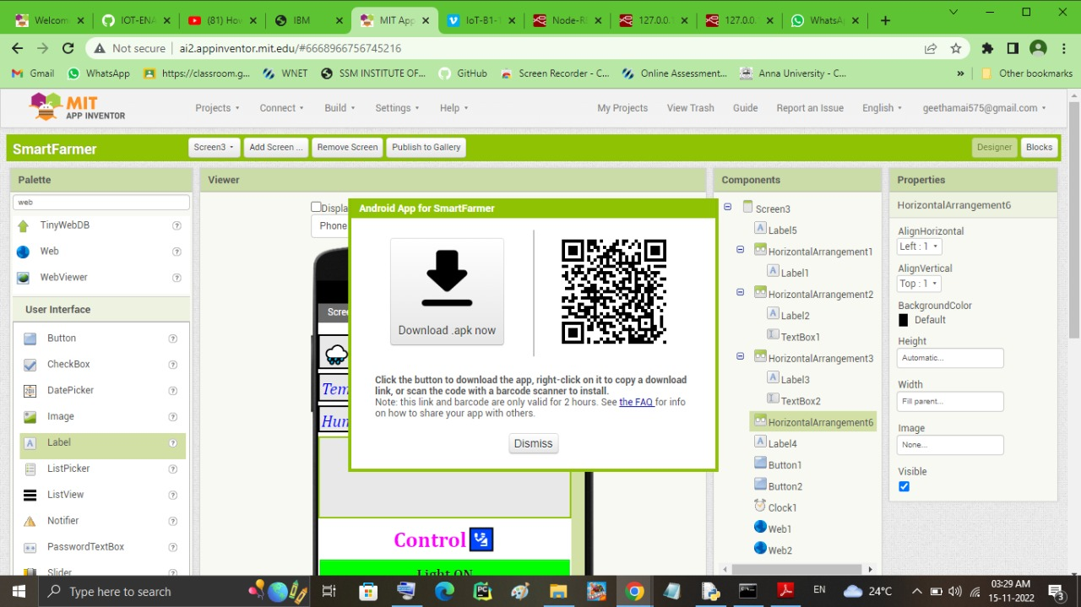 REGISTRATION AND LOGIN SCREEN :

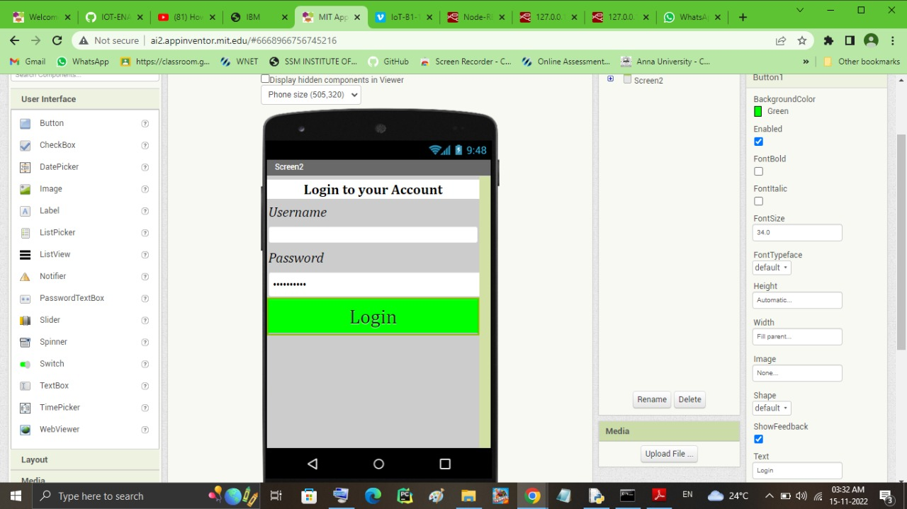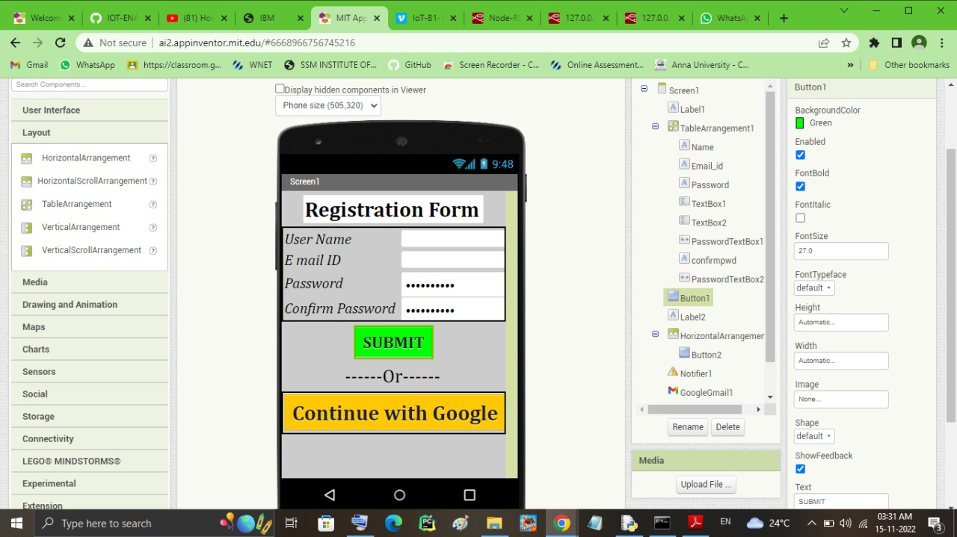

OUTPUT SCREEN:

